7.1 User Interface Summary
The game will consist of two main types of user interface: menu and gameplay. In the menu sections, the user will navigate using the mouse to click on labelled options. In the gampelay section the section will use 9 keys to play the game. The game controls can be customised in the Settings menu. The default layout will be W, A, S, D to move up, left, down and right respectively. UP ARROW, LEFT ARROW, DOWN ARROW and RIGHT ARROW will be the default keys for shooting up, left, down and right respectively. Finally the default key to pause the game will be ESC.

7.2 Screen Images
7.2.1 Splash Screen Prototype
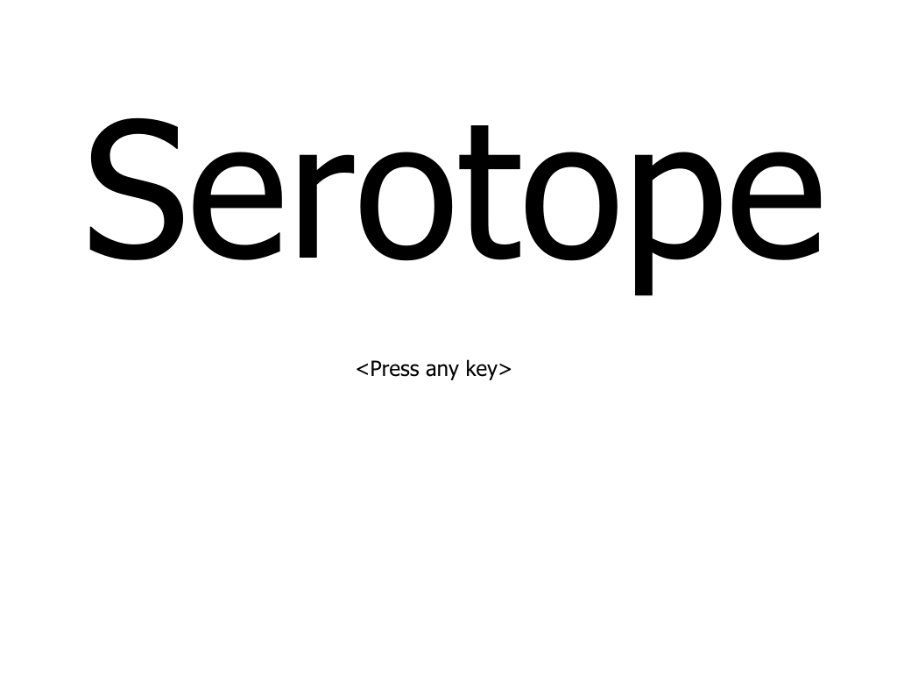
7.2.2 Main Menu Prototype
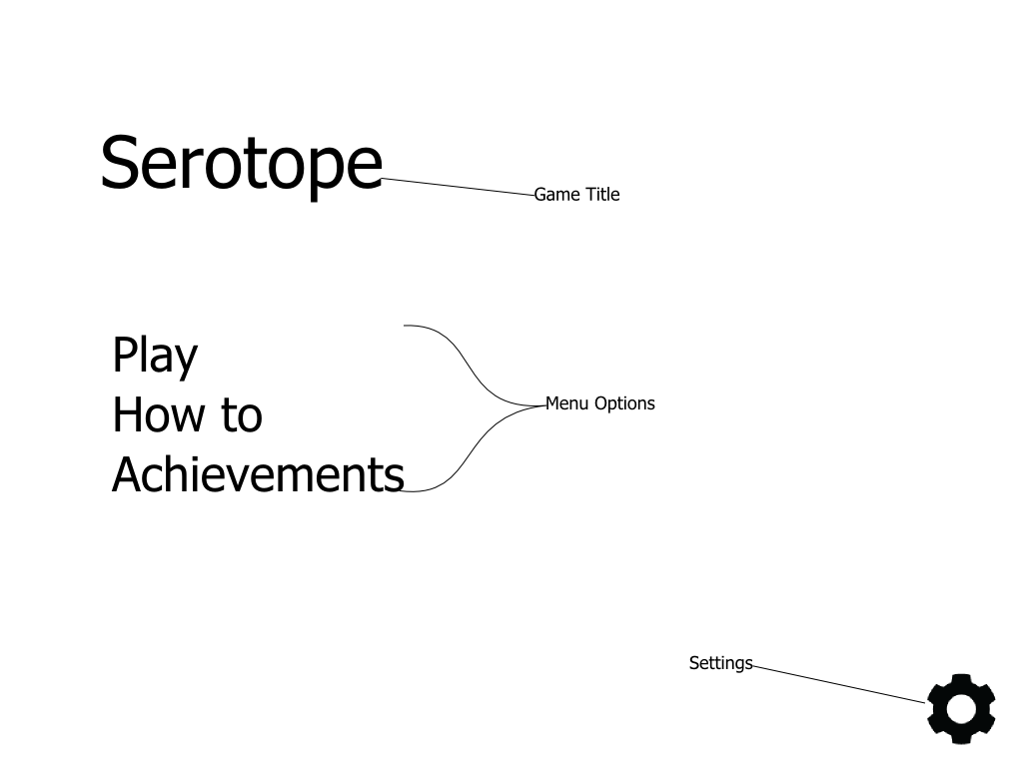

7.2.3 Tutorial Prototype
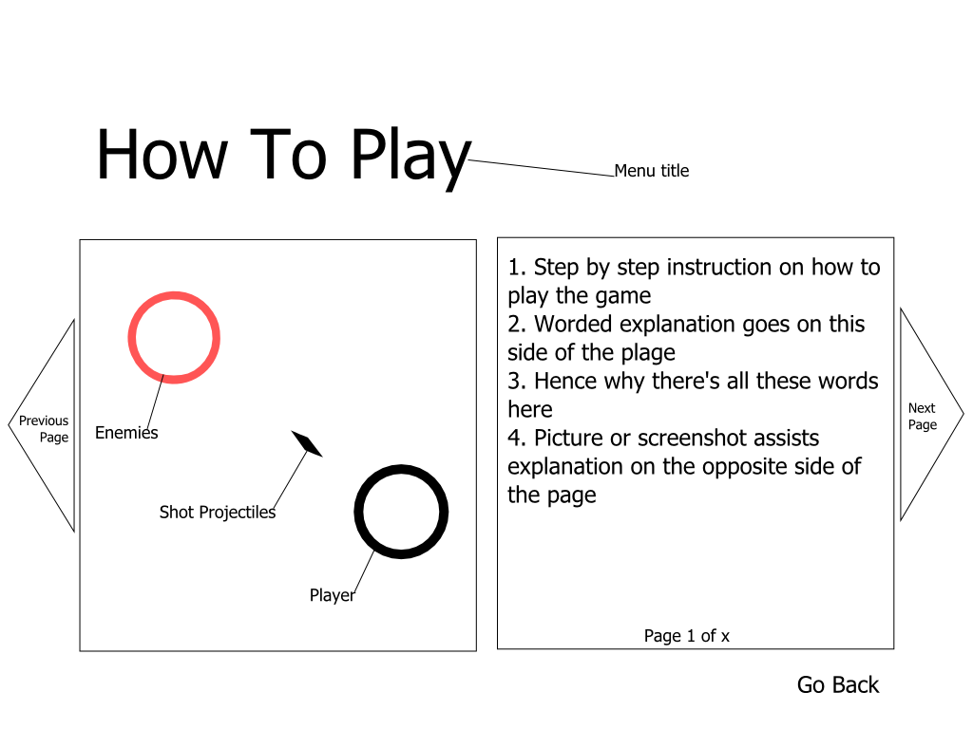

7.2.4 Achievements Prototype
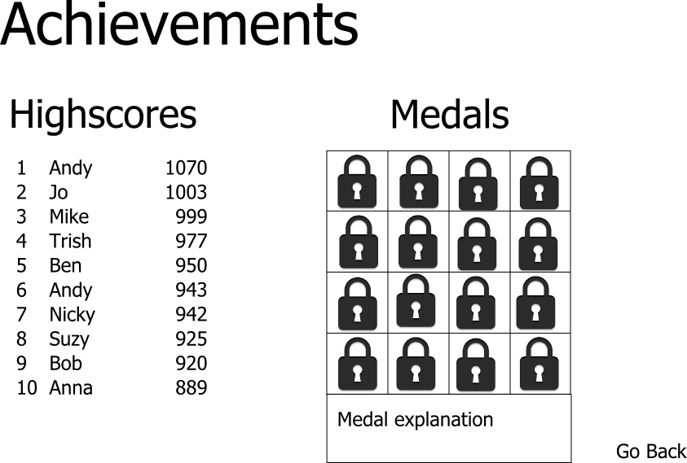

7.2.5 Settings Prototype

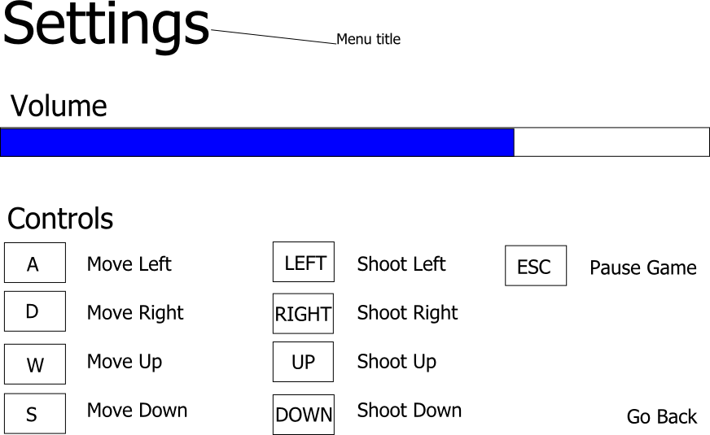

7.2.6 Gameplay Prototype
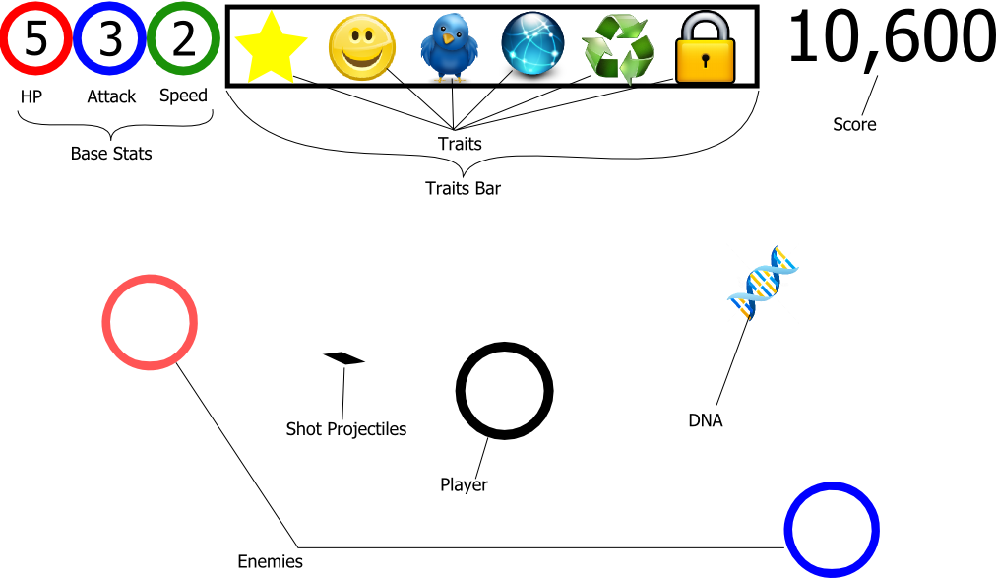

7.2.7 Pause Menu Prototype

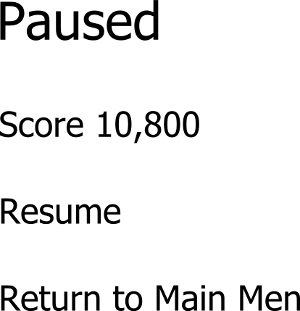

7.2.8 Game Over Prototype

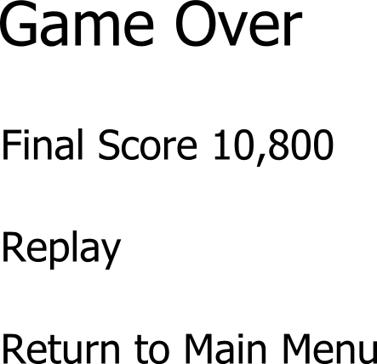

7.3 Screen Objectives and actions
7.3.1 Splash Screen
The screen which will be loaded when the user opens the program. The user enters the Main Menu section from here by simply pressing any key like the instruction prompts them to

7.3.2 Main Menu
From here the user has access to all the features of the program. There are 4 four options: Play Game, Tutorial, Achievements or Settings. Every option is labelled except the Settings which is the cog symbol at the bottom right of the screen. Each option is accessed by mouse clicking on the button.

7.3.3 Tutorial Menu
Provides an explanation of the game to the user. Text instructions are displayed on the right half of the screen with an assisting picture on the left hand side. The user navigates the tutorial by mouse clicking on the triangles on the screen edges labelled “Next Page” and “Previous Page”. To return to the Main Menu the user must mouse click of the “Go Back” option at the bottom right hand of the screen.

7.3.4 Achievements Menu
Displays the top 10 scores of the game in ranked order from highest to lowest on left half of the screen. On the right hand side the medal table is displayed. The user can mouse click on each medal box and an explanation of the text box below will give a text explanation on how the medal can be unlocked. If the medal has been achieved, the medal image will be display otherwise a locked symbol will be displayed in the box instead. To return to the main menu the user can mouse click the “Go Back” option.

7.3.5 Settings Menu
Here the user can customise some of the game settings. This consists of editing the game volume displayed as a sound bar. The user can mouse click or drag anywhere on the bar to set the volume. The user is also able to edit the gameplay controls here. To change a key setting the need to mouse click on the box, where the current key been used is, and then press the key they would prefer to use instead. To return to the main menu the user can mouse click the “Go Back” option.

7.3.6 Gameplay
In the game the user controls a single creature in the game. The user can move the creature using the W, A, S and D keys and shoot projectiles with UP ARROW, LEFT ARROW, DOWN ARROW and RIGHT ARROW, unless they have customised the controls in the settings menu. The user can also pause the game at any point using the default ESC key unless that has been changed. The camera for the game is centred on the player controlled creature so it is typically rendered at the middle of the screen.

7.3.7 Pause Menu
The pause game displays the player’s current score and allows two options that they can select by mouse clicking on them. They can either choose the “Resume” option where they leave the pause menu and return to the current game, or they can choose to “Return to Main Menu” which returns the player to the main menu screen and the current game’s progress is ended.

7.3.8 Game Over Menu
This menu displays the final score of that game and 2 options. The user can either choose to “Play Again” which starts a new game or to “Return to Main Menu” which will take them back to the main menu

Glossary
medal – an unlockable individual achievement for the game

